Contents

Module 2 2

Point of Sale (PoS) Case Study 2

Requirement Categories - Functional & Non Functional Requirements 3

PERT, Project What is Use Case Diagram & Use Cases? 3

Overview of Unified Process 4

Types of Use Cases 5

Write Fully Dressed Use Case for one scenario in PoS System 6

Styles of Use Cases 7

Module 3 8

Domain model 8

How domain model is represented in uml 9

Identification of domain concepts from use case 10

Identification of relationships among domain concepts 13

Finding Multiplicity among Domain Concepts 14

Adding attributes to Domain Model 15

Significance of Domain Model 17

What is Sytem Sequence Diagram? 18

Significance of SSD 18

Drawing SSD for PoS 18

What is operator contractor 19

Represent Operation Contract in UML 20

Module 4 21

Relating Use Cases: includes, extends relationships 21

Refining Domain Model: Derived Attributes 22

Refining Domain Model: Association Classes 23

What is Interaction Diagram 24

Types of Interaction Diagrams 25

Representation of Interaction Diagrams in UML 26

# Module 2

## Point of Sale (PoS) Case Study

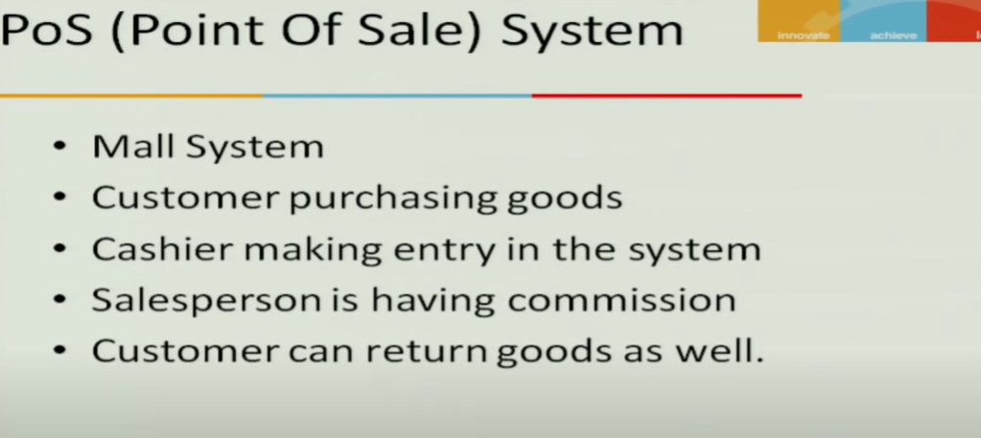

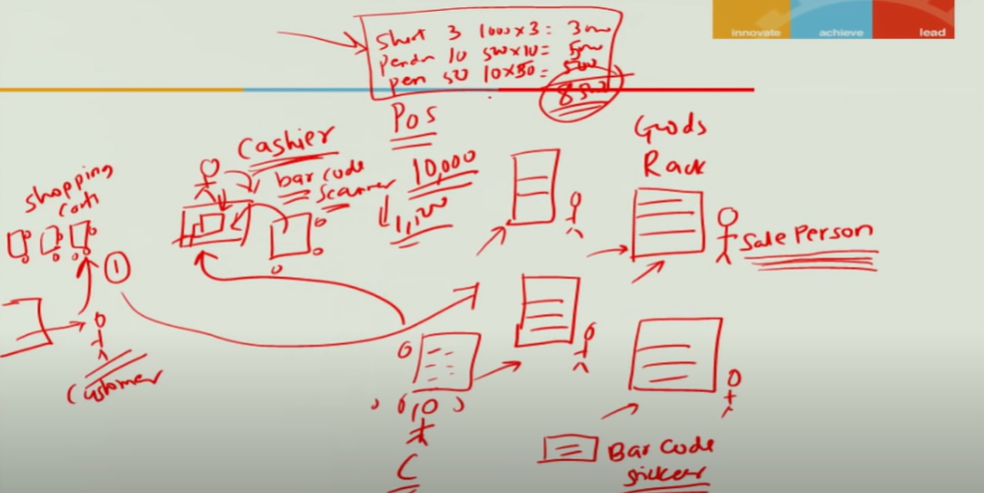

## Requirement Categories - Functional & Non Functional Requirements

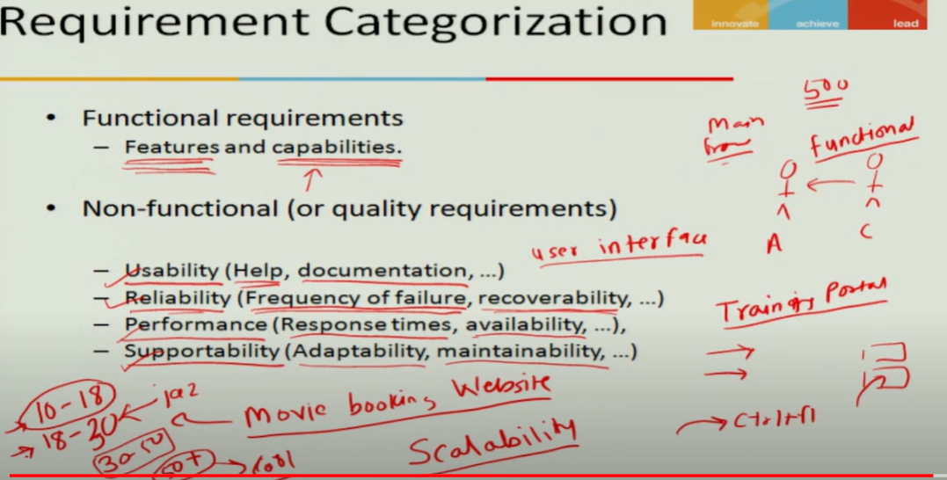

## PERT, Project What is Use Case Diagram & Use Cases?

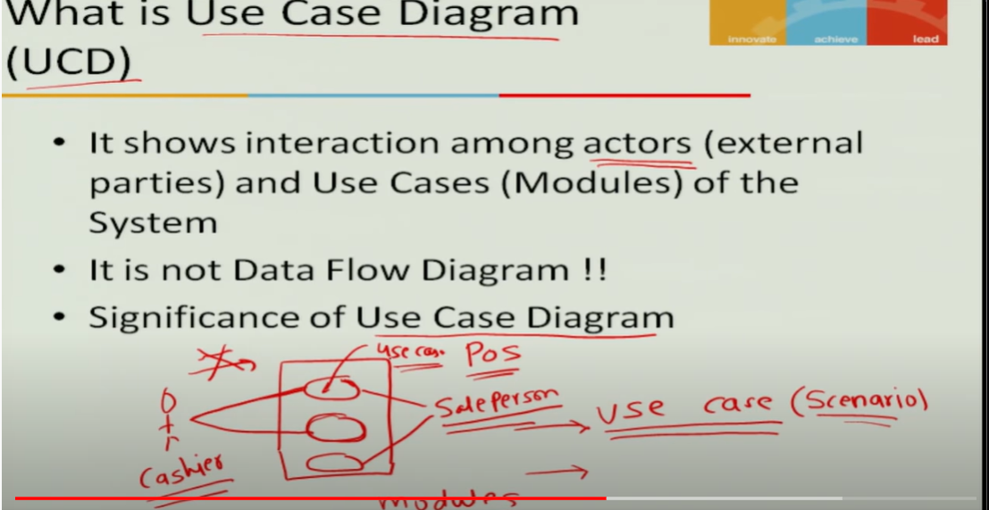

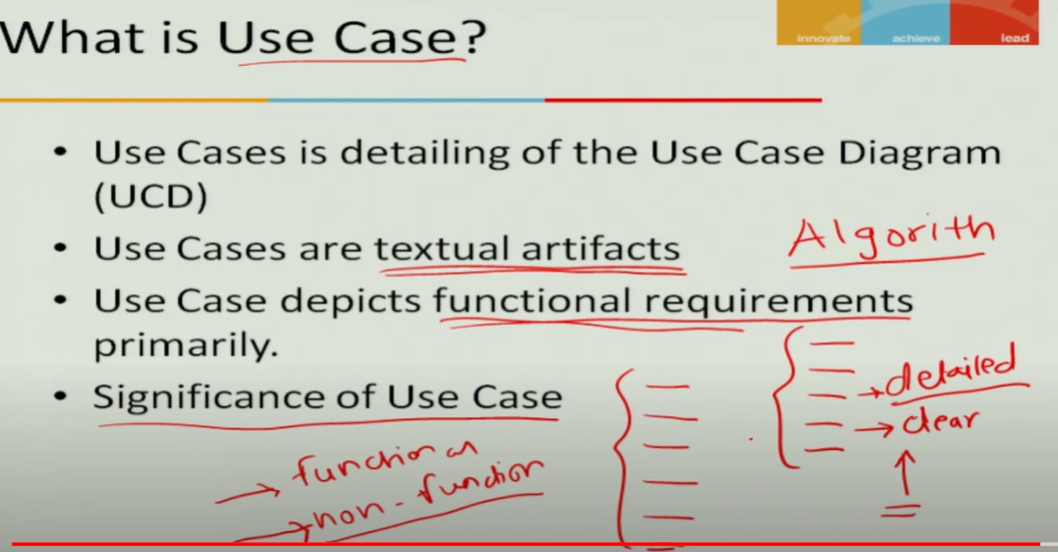

## Overview of Unified Process

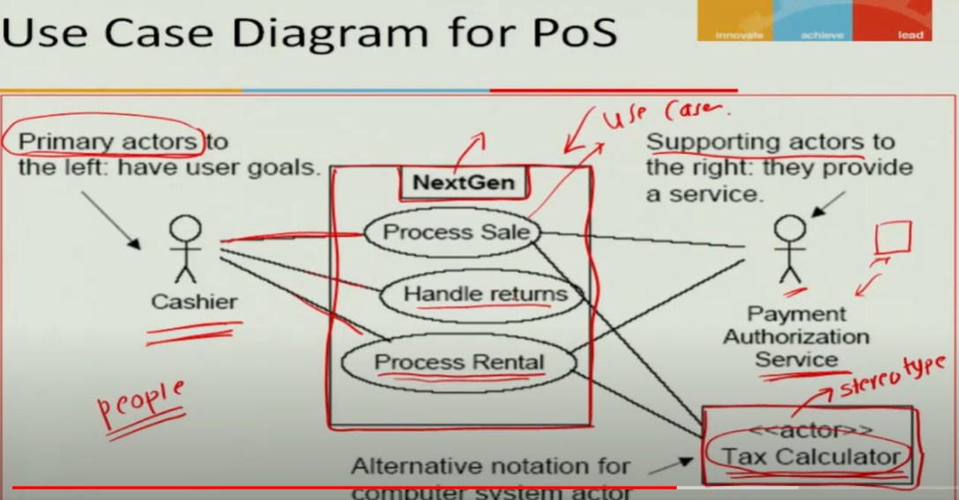



## Types of Use Cases

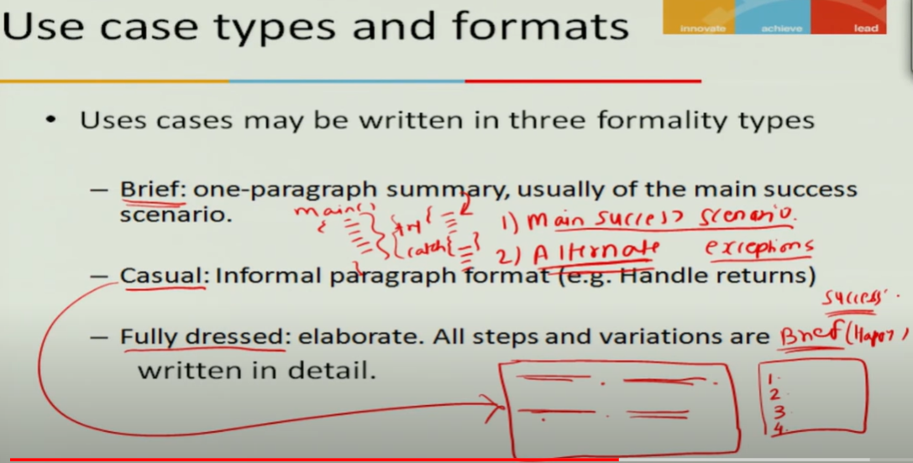

## Write Fully Dressed Use Case for one scenario in PoS System

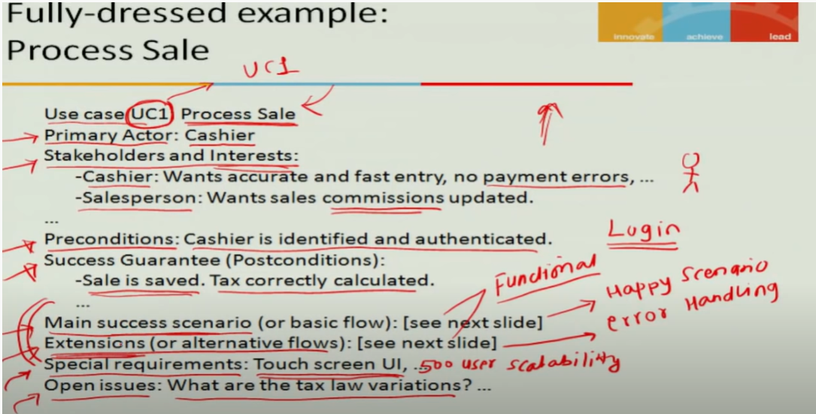



## Styles of Use Cases

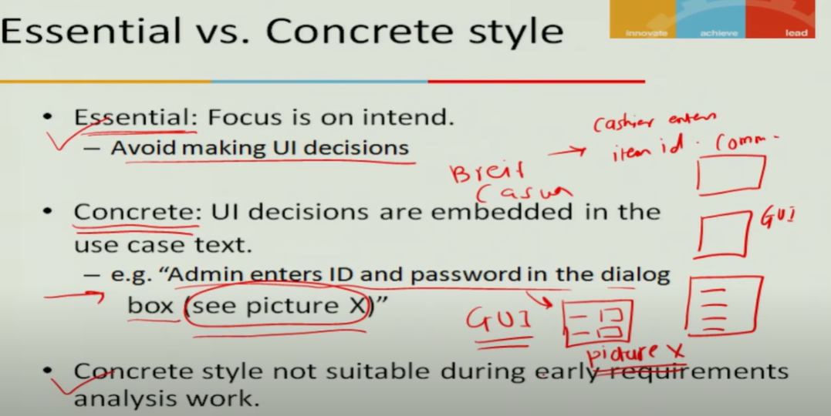

# Module 3

## Domain model

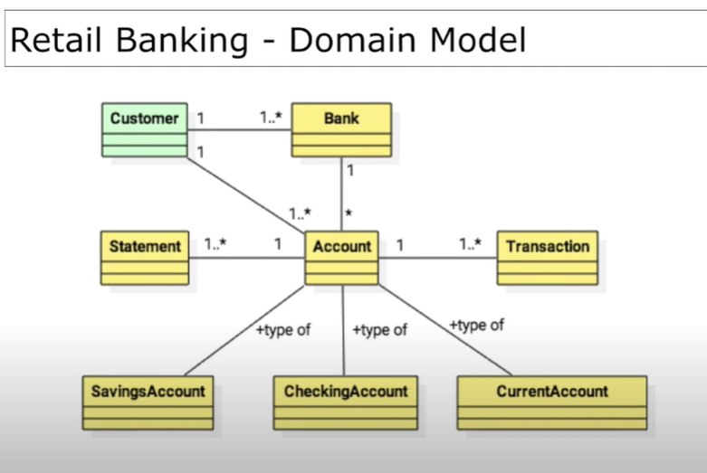

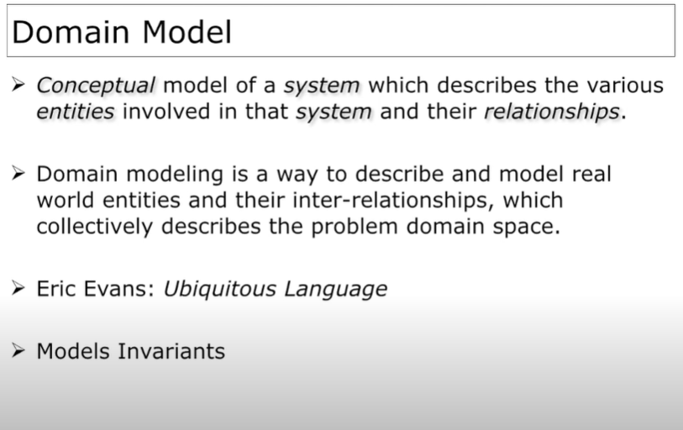

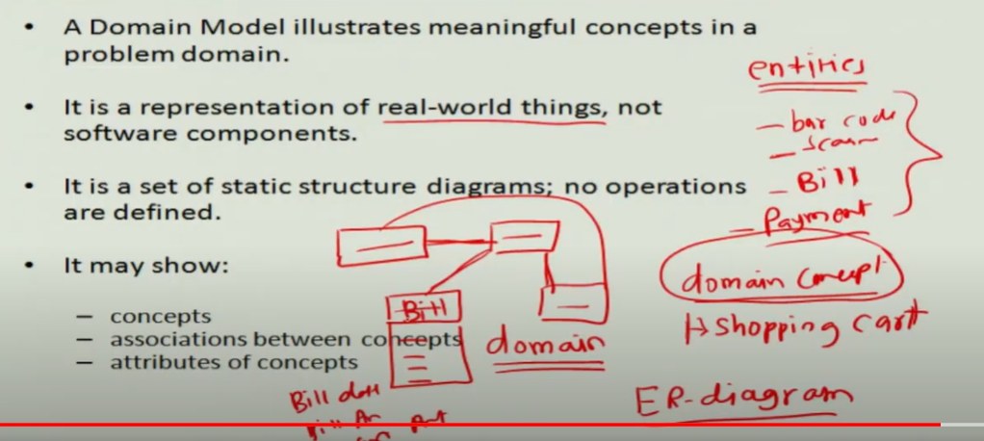

## How domain model is represented in uml

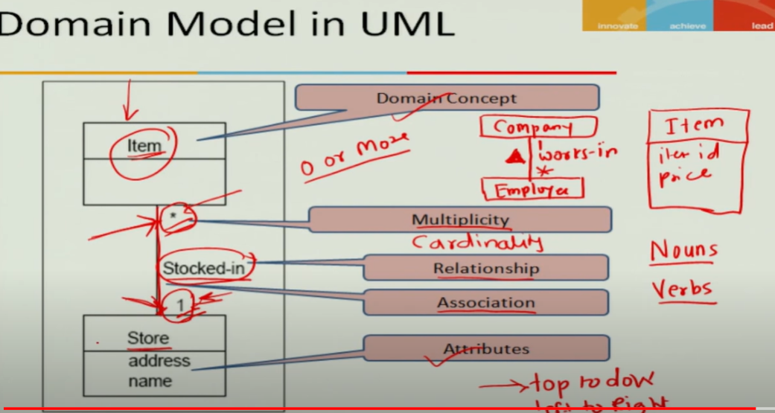

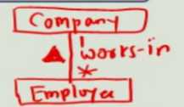

No tenary is allowed (as shown in below diagram)



## Identification of domain concepts from use case

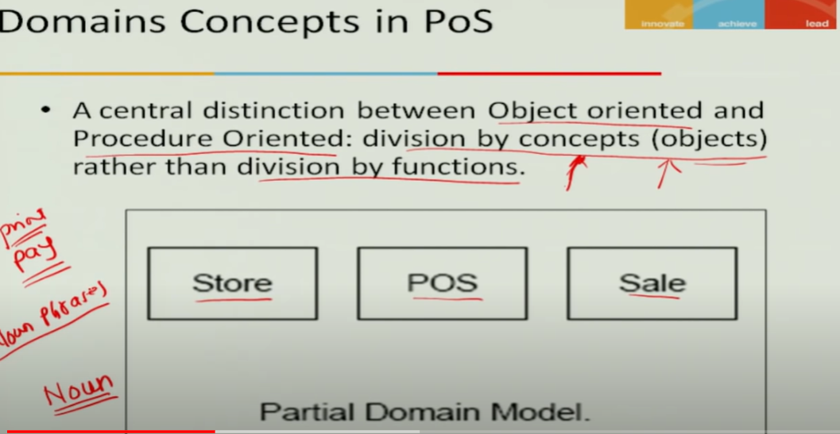



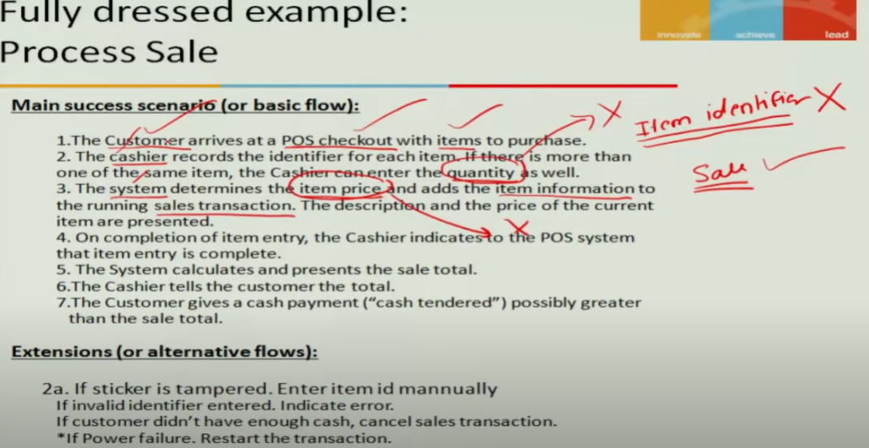

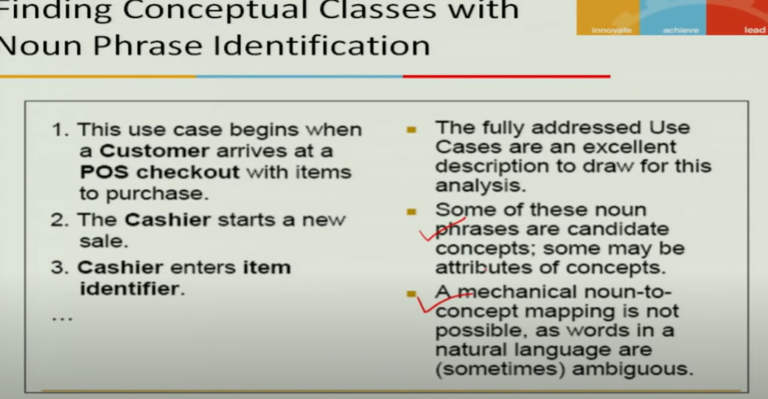



You can identifiy domain concept by noun phrase analysis technique

## Identification of relationships among domain concepts

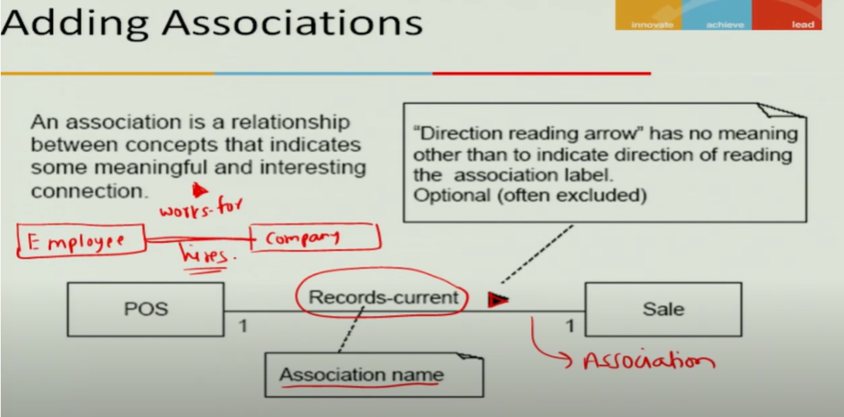

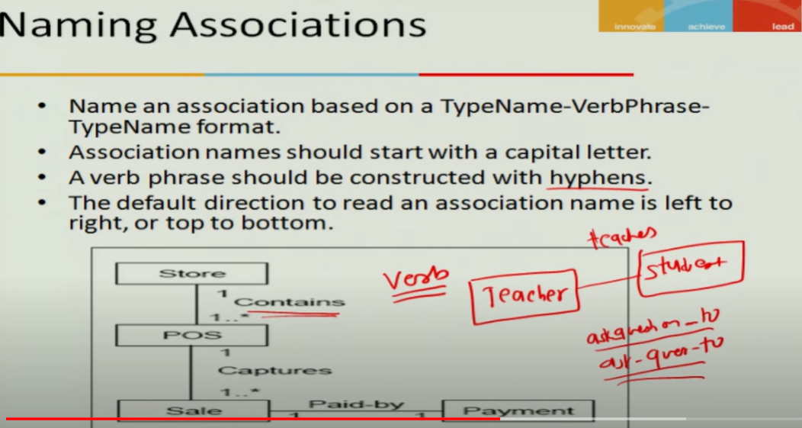

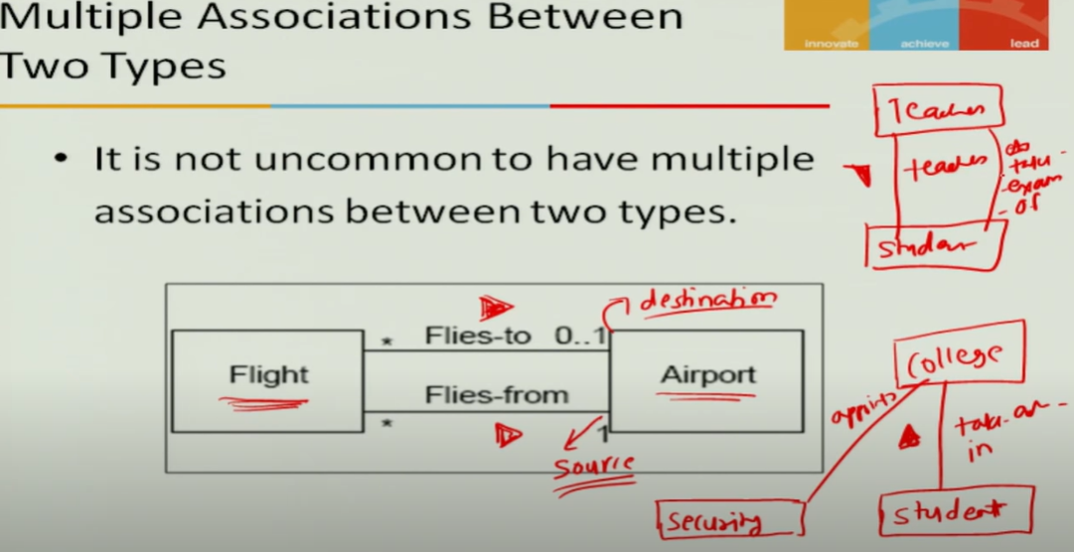

## Finding Multiplicity among Domain Concepts

Multiplicity is also known as cardinality , cardinality is adopted by ER diagram

Procedure oriented we draw er diagram

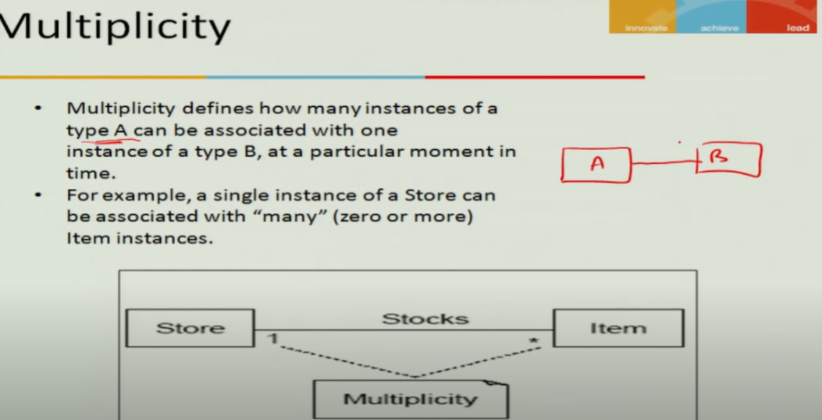

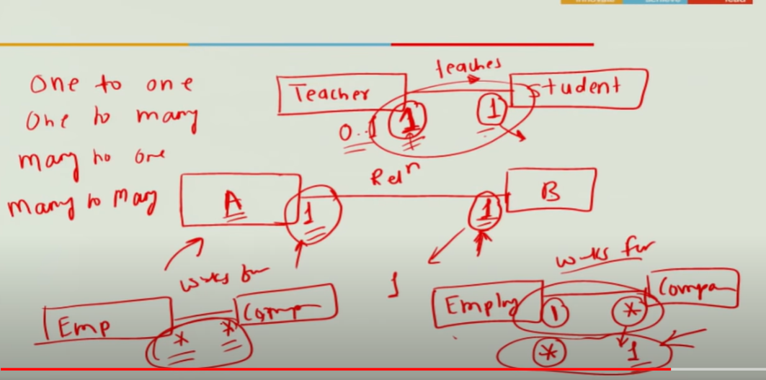

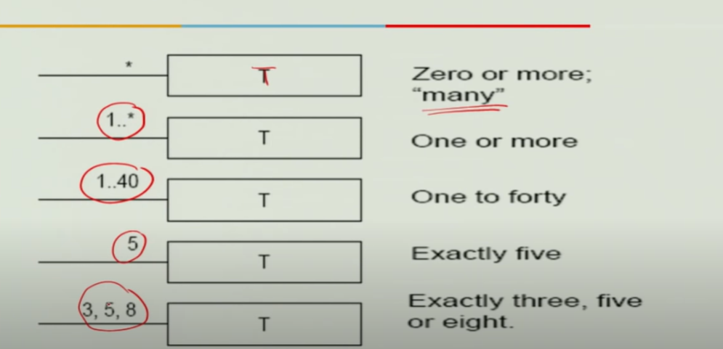

## Adding attributes to Domain Model

Attributes are properties of entities

Id – programming attributes (not required in domain)

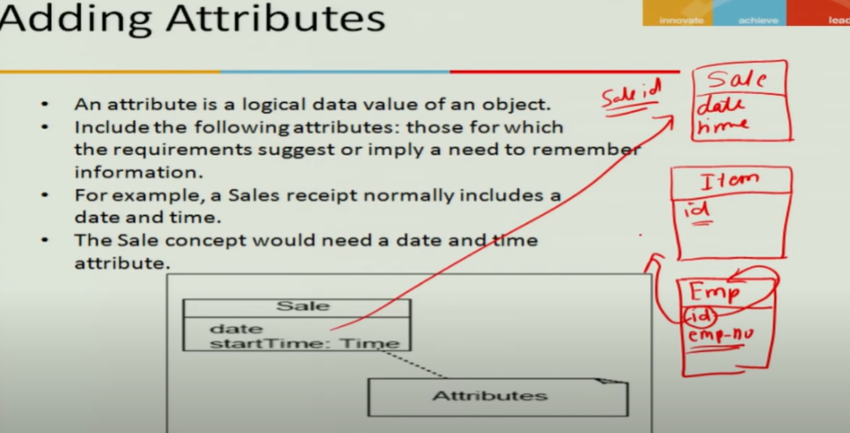

Don’t use complex domain concept as attribute (like sales or airport or register)

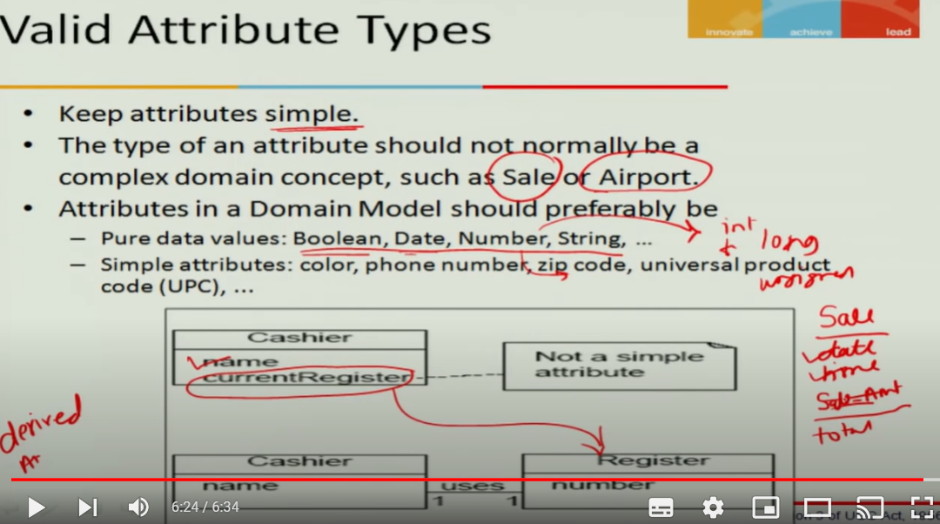

## Significance of Domain Model

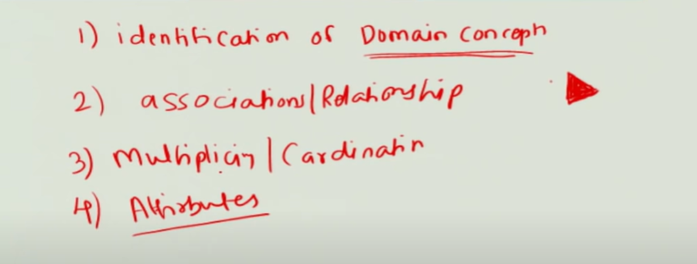

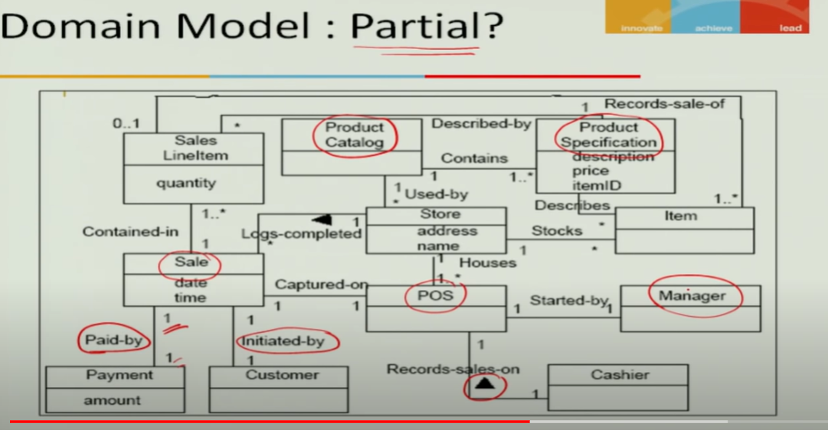



## What is Sytem Sequence Diagram?

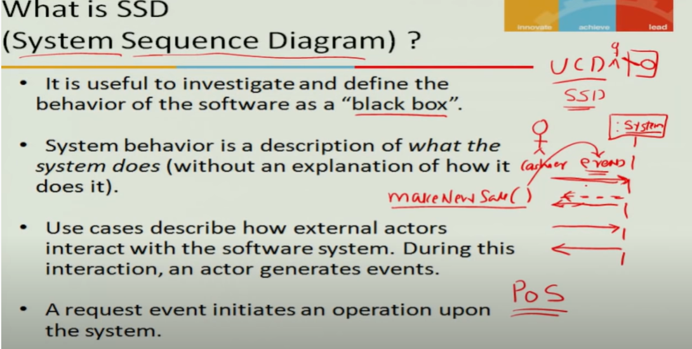

## Significance of SSD

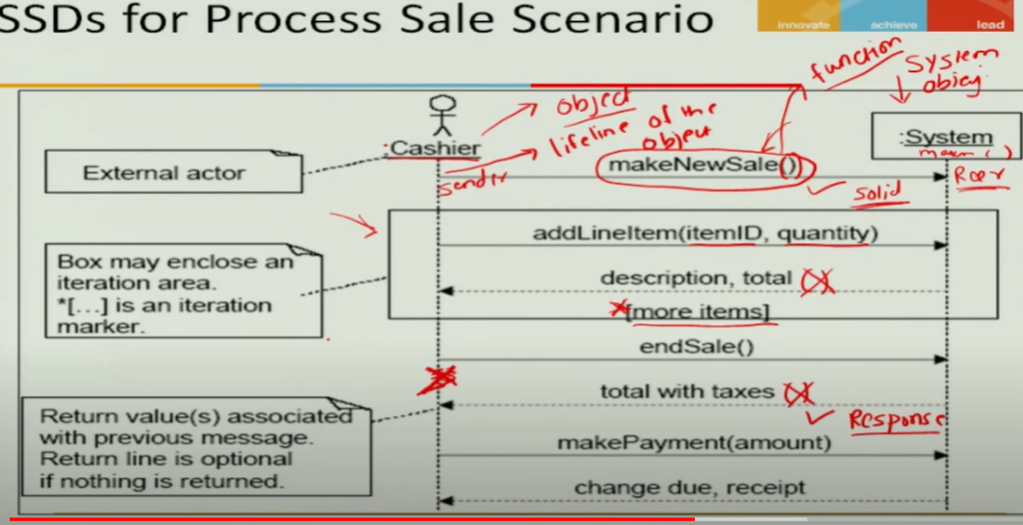

## Drawing SSD for PoS

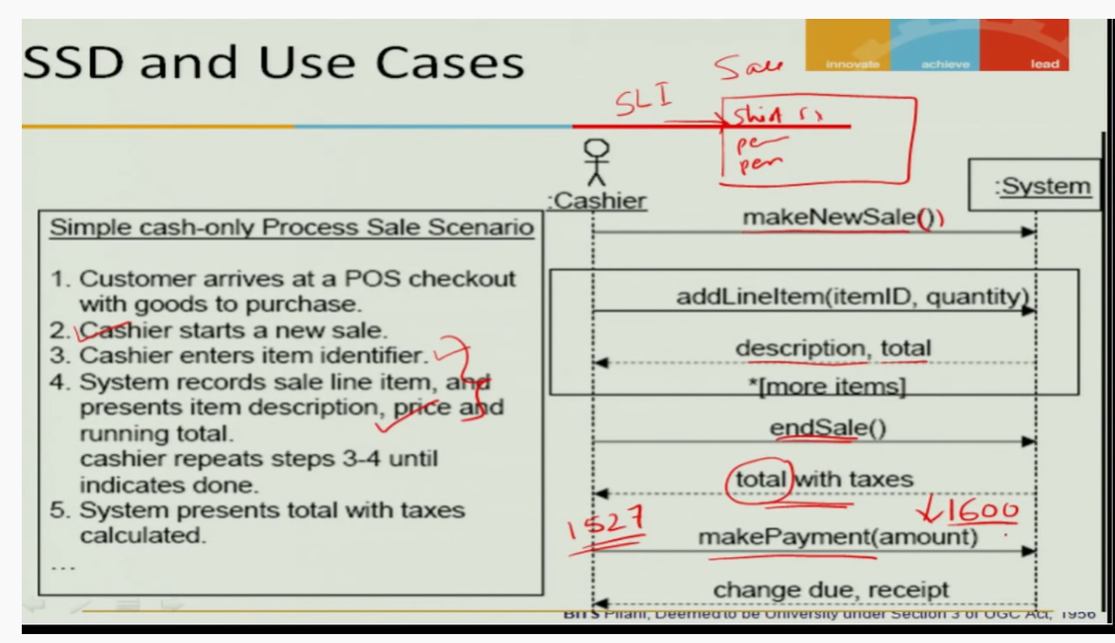

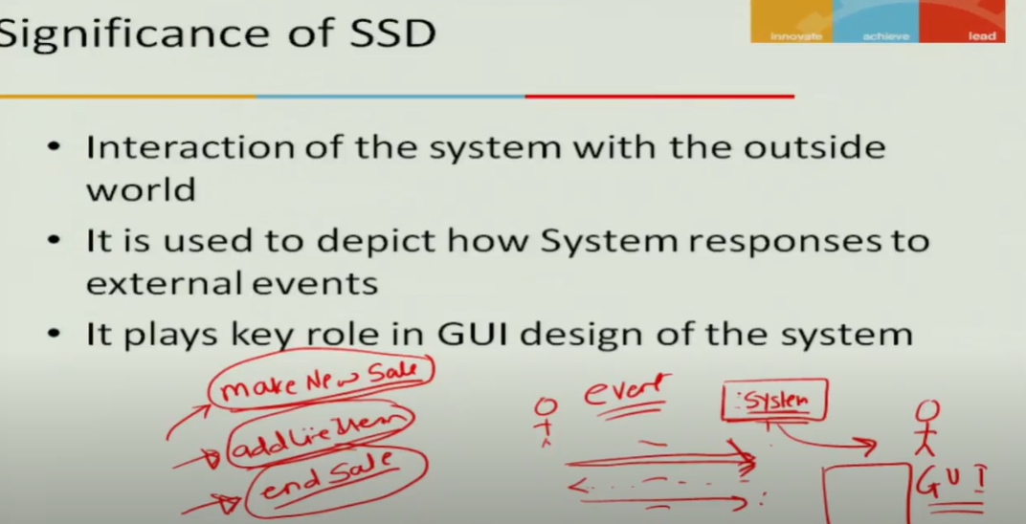

## What is operator contractor

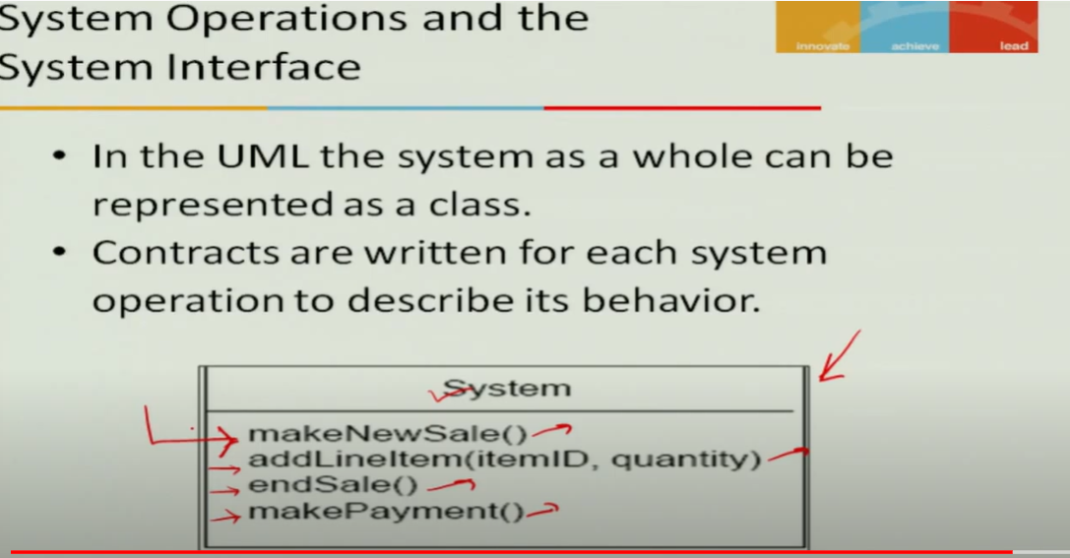

## Represent Operation Contract in UML

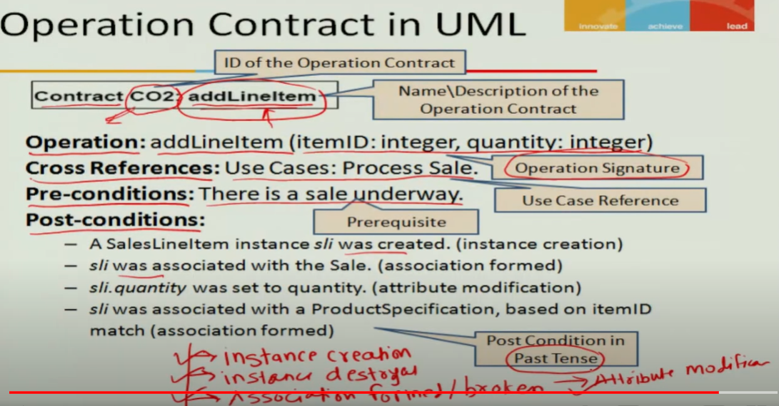

# Module 4

## Relating Use Cases: includes, extends relationships

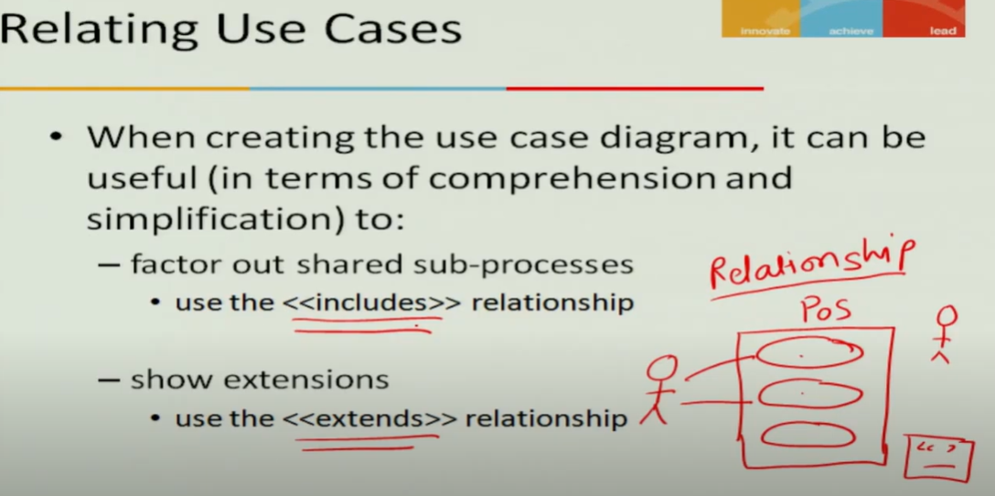

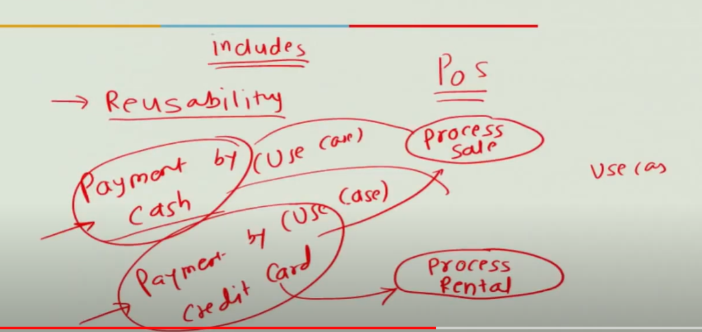

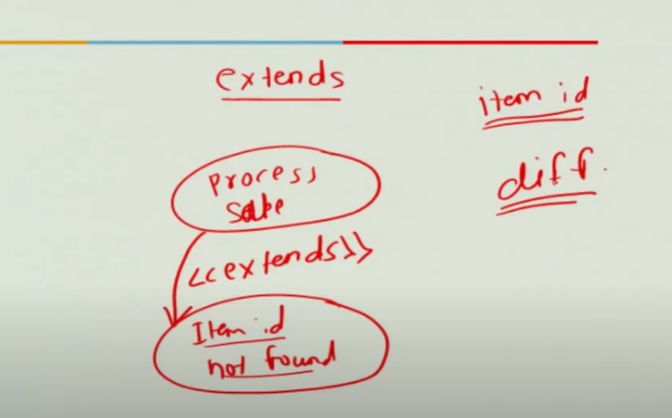



## Refining Domain Model: Derived Attributes

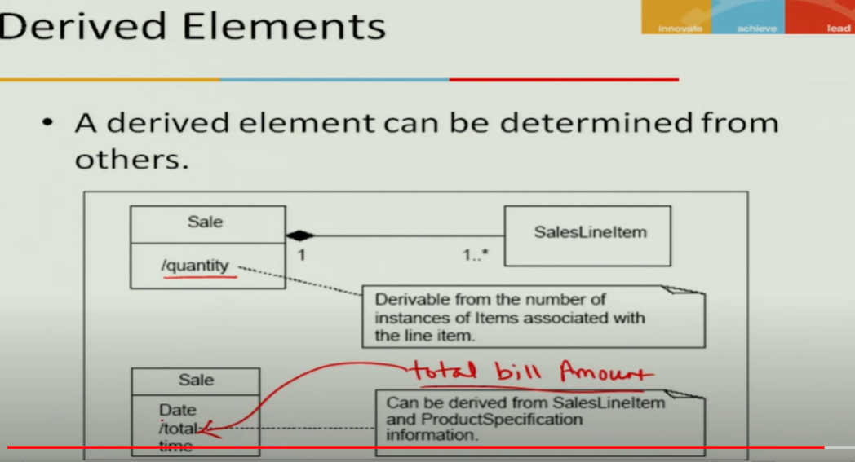

## Refining Domain Model: Association Classes

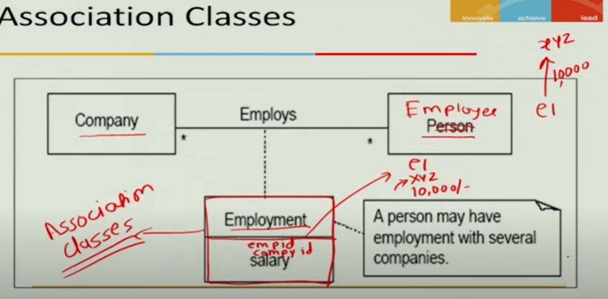



## What is Interaction Diagram

Interaction of diagram within system

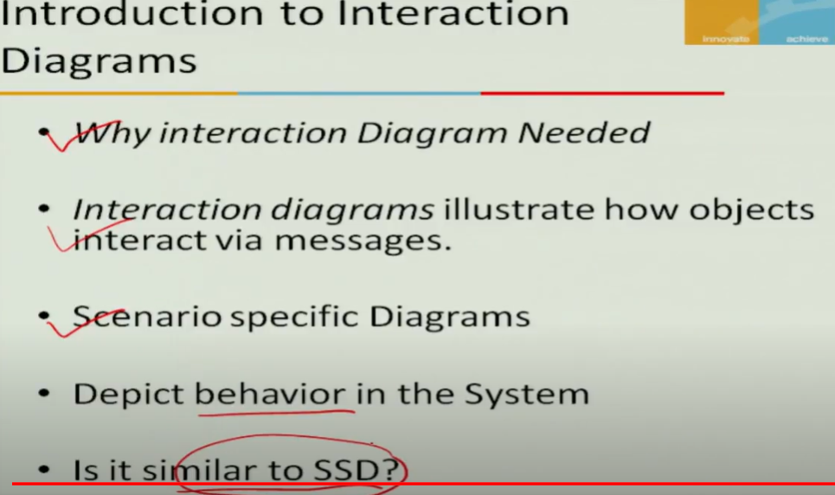

## Types of Interaction Diagrams

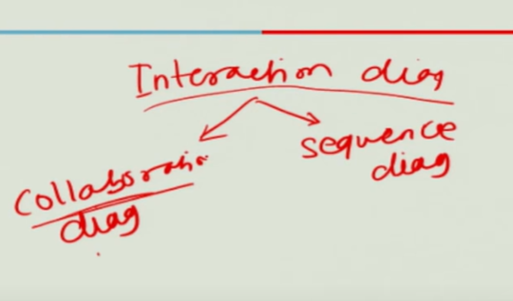

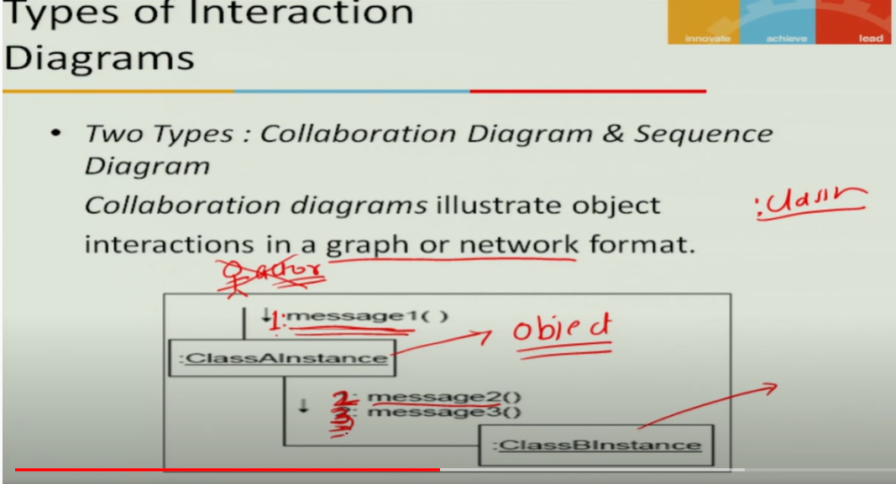

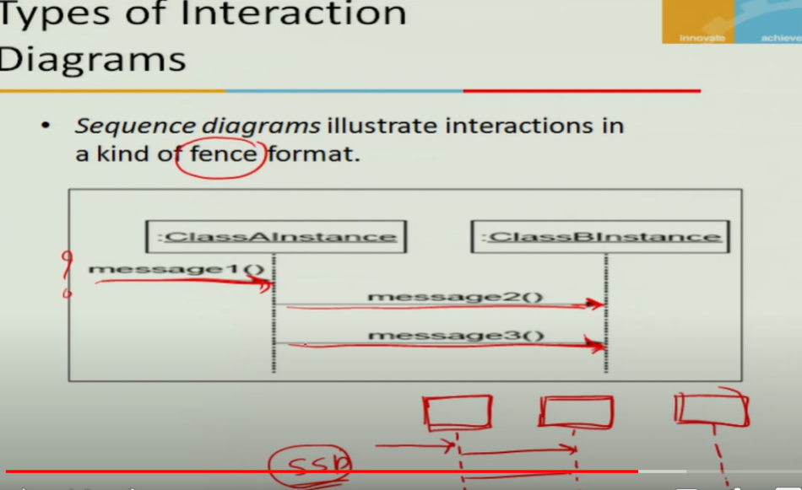

Many objects and less messages then go for collaboration diagram

If limited objects and many messages then go for sequence diagram

Most of time – sequence diagram will be used

## Representation of Interaction Diagrams in UML

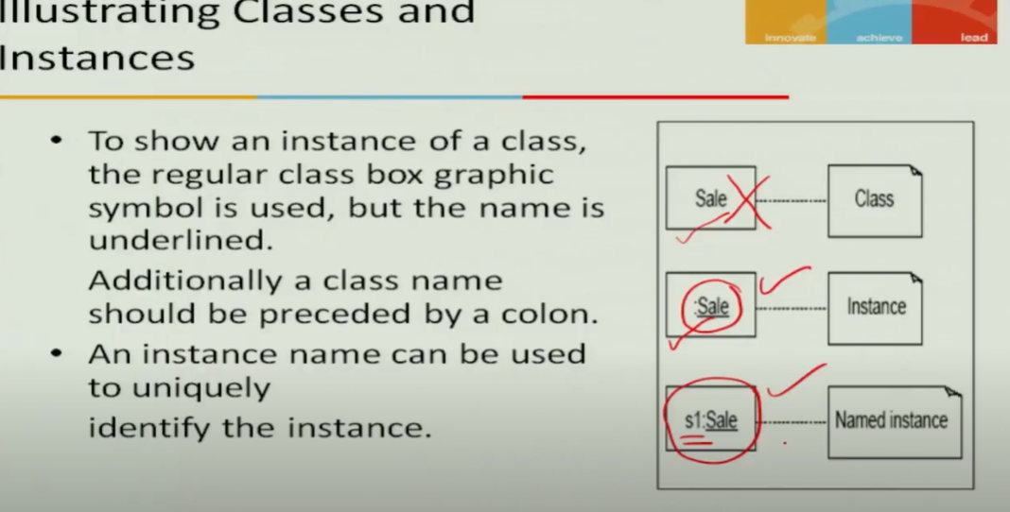

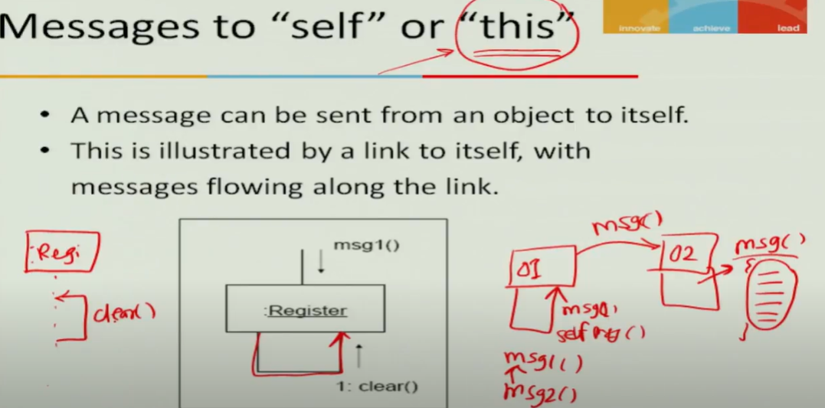

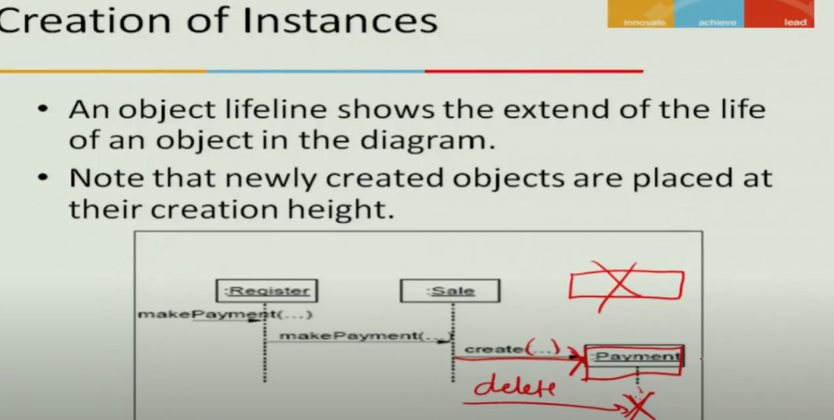

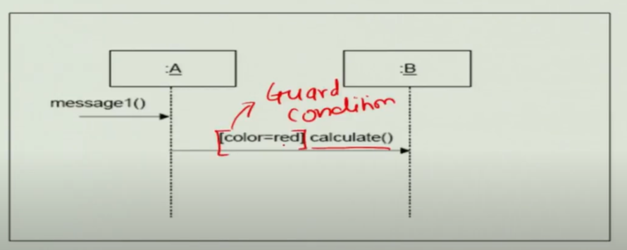

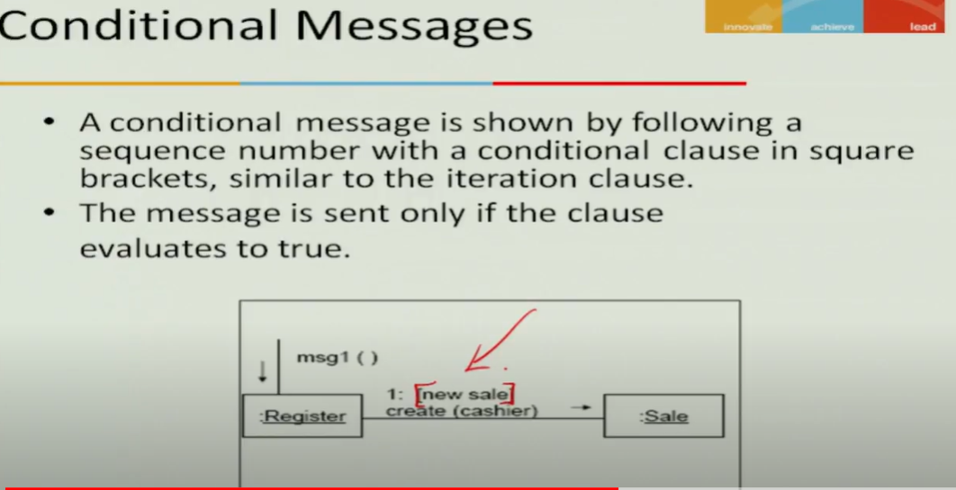

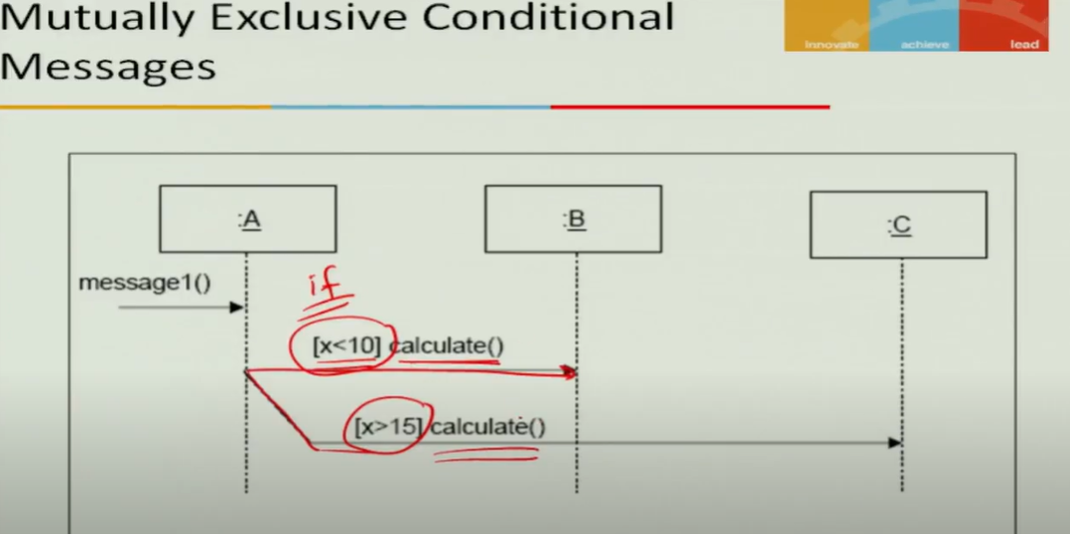

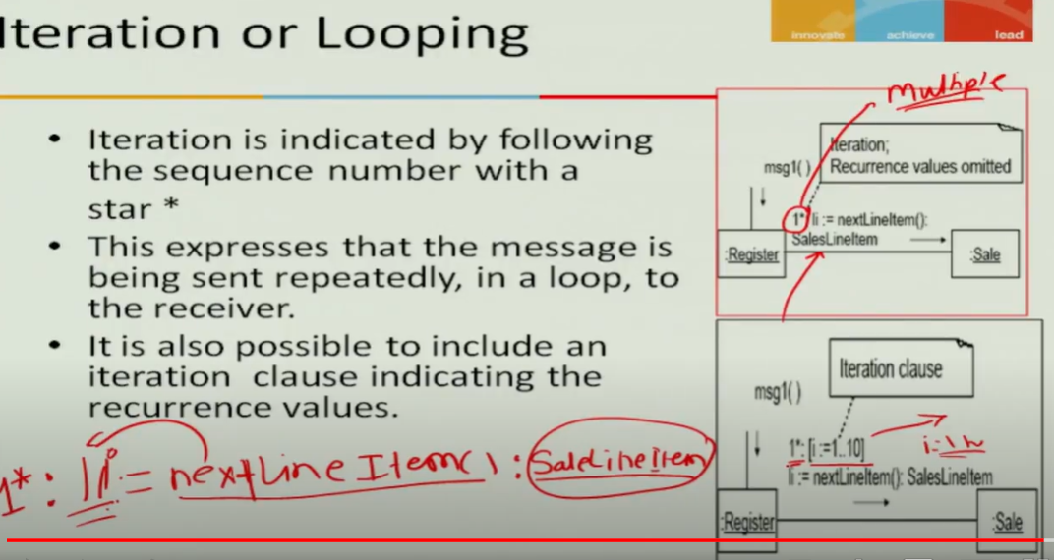

## Drawing Interaction Diagrams for PoS

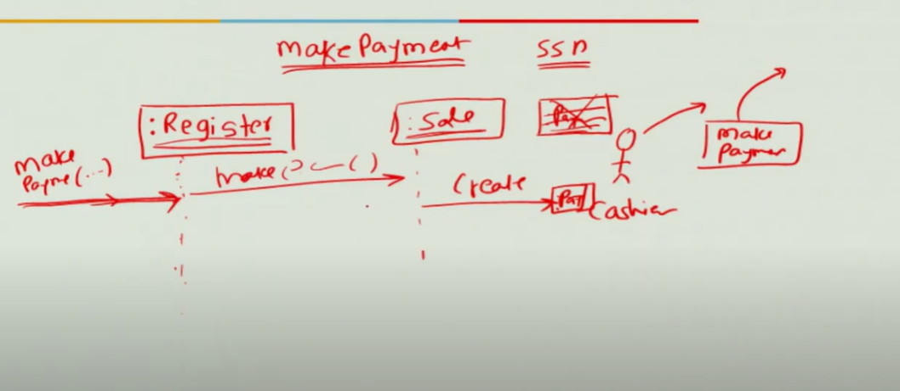

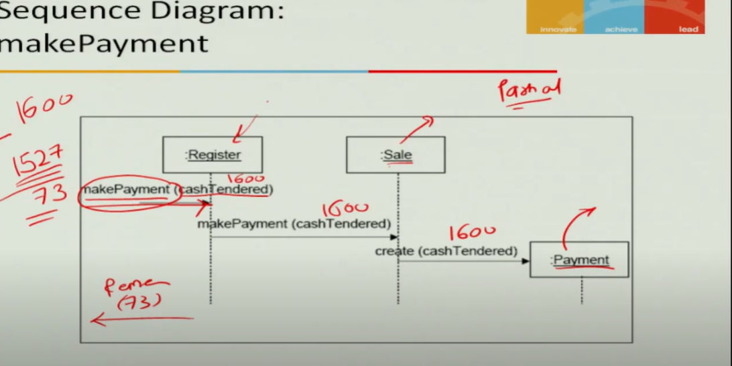

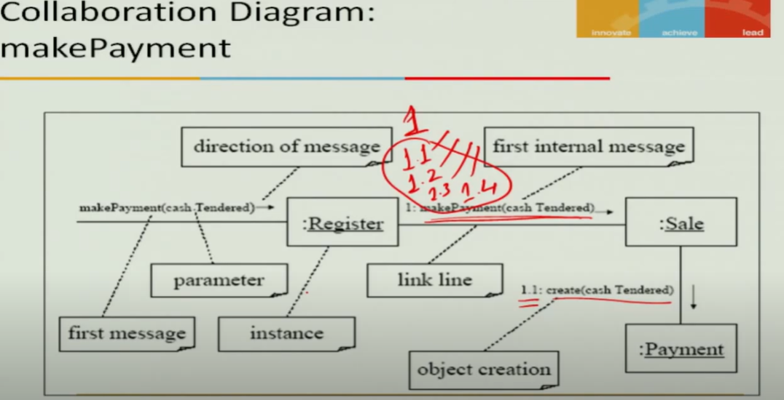

## Introduction to State Transition Diagram

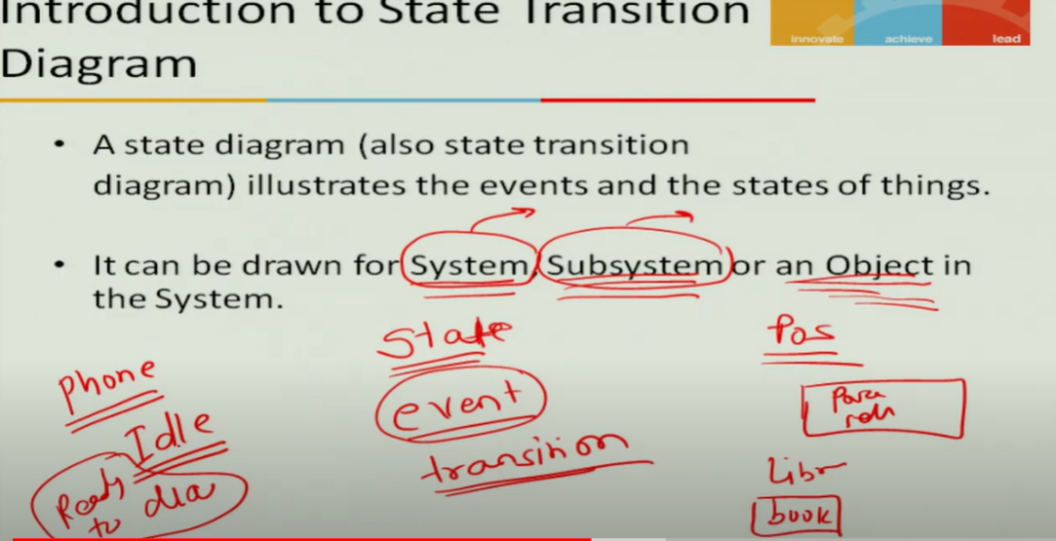

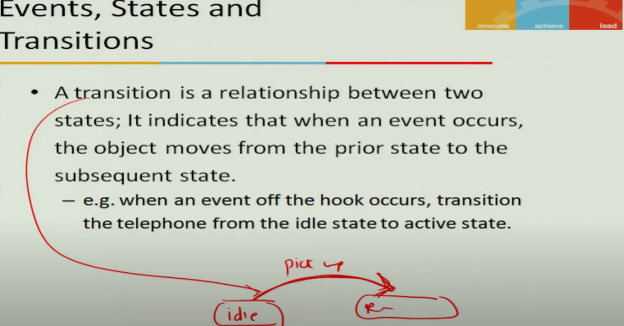

## Representing State Transition Diagram in UML

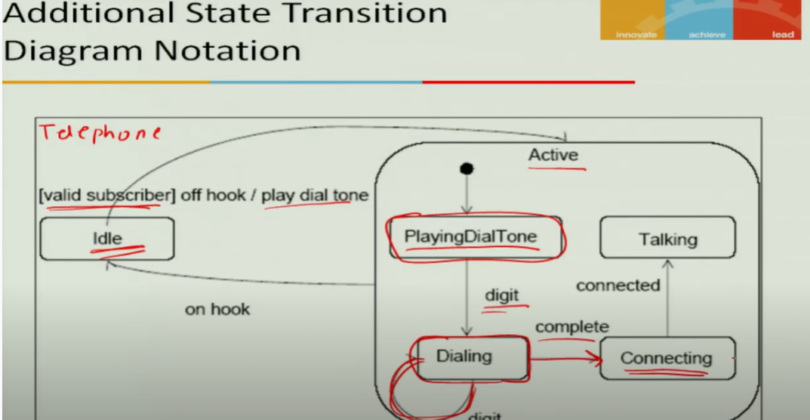

## What is Activity Diagram

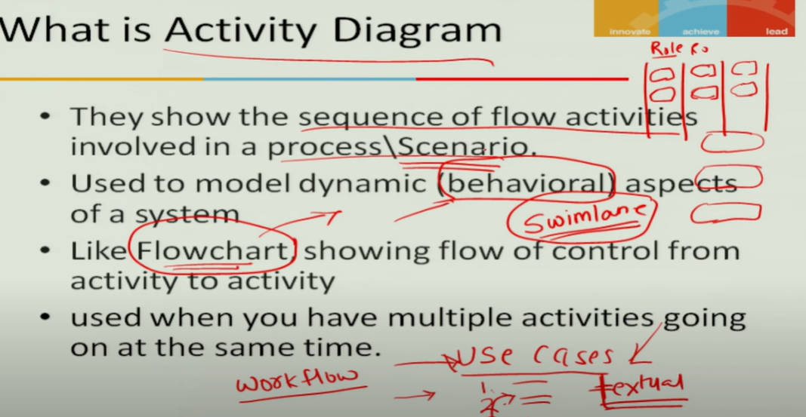

## Representing Activity Diagram in UML

